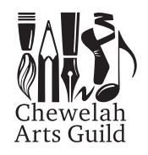
Our Mission is to support the growth, development, appreciation and understanding of the arts in their various forms and to make the arts accessible to all members of the greater Chewelah community.

Dear Artist/Supporter of the Arts,
The Chewelah Arts Guild is inviting you to be a member for the 2023-2024 year.

The proposed 2023 Chewelah Arts Guild events include:
- Chewelah Annual Art Show, February 17 – 19, 2023
- Pecha Kucha, March 22, 2023
- Chewelah Arts Guild Annual Quilt Show, May 27 & 28, 2023
- Chewelah Arts Guild Annual Quilt Walk, TBD
- Children’s Art Festival, July 15 & 16, 2023
- Pecha Kucha, TBD
- A Taste of Chewelah/Art Auction, September 14, 2023
Please join the Guild or renew your membership and let us know how you would like to contribute to Art Guild activities.
Our membership year runs from June 1st to May 31st.
- Annual Dues: $25 Individual; $35 Family/Organization; or $15 Senior/Student
- Would you like to make an additional tax deductible donation to the Arts Guild? $_______
Please make checks payable to Chewelah Arts Guild, a non-profit 501(c) 3; therefore, tax deductible.
Please complete the form below and return to Chewelah Arts Guild. PO Box 1437, Chewelah, WA 99109 or go to the website, www.chewelahartsguild.org, to complete the information there and use PAYPAL to pay your dues.
Name(s)
Mailing Address
Home Phone _______________ Cell Phone E-mail ___________________________________

Please check events to which you would like to volunteer to help:
 | Art Show |  | Pecha Kucha
 | A Taste of Chewelah |  | Pencil Drawing
 | Baking/Event Set Up/Decorating |  | Light up the Town
 | Children’s Art Festival |  | Rainbow Grant/Scholarship Selection
 | Art Classes/Workshops |  | Roadside Cleanup
 | Grant Writing/Donation Drives |  | Writing Articles/Ad Creation
 | Quilt Walk/Show |  | Website Management
 | Social Media Management |  | Other _________________________________

What activities would you like to see the Arts Guild continue or initiate? _______________________________________________
________________________________________________________________________________________________________________________________________________________________________________________________________________

How did you hear about us? _________________________________________________________________________________
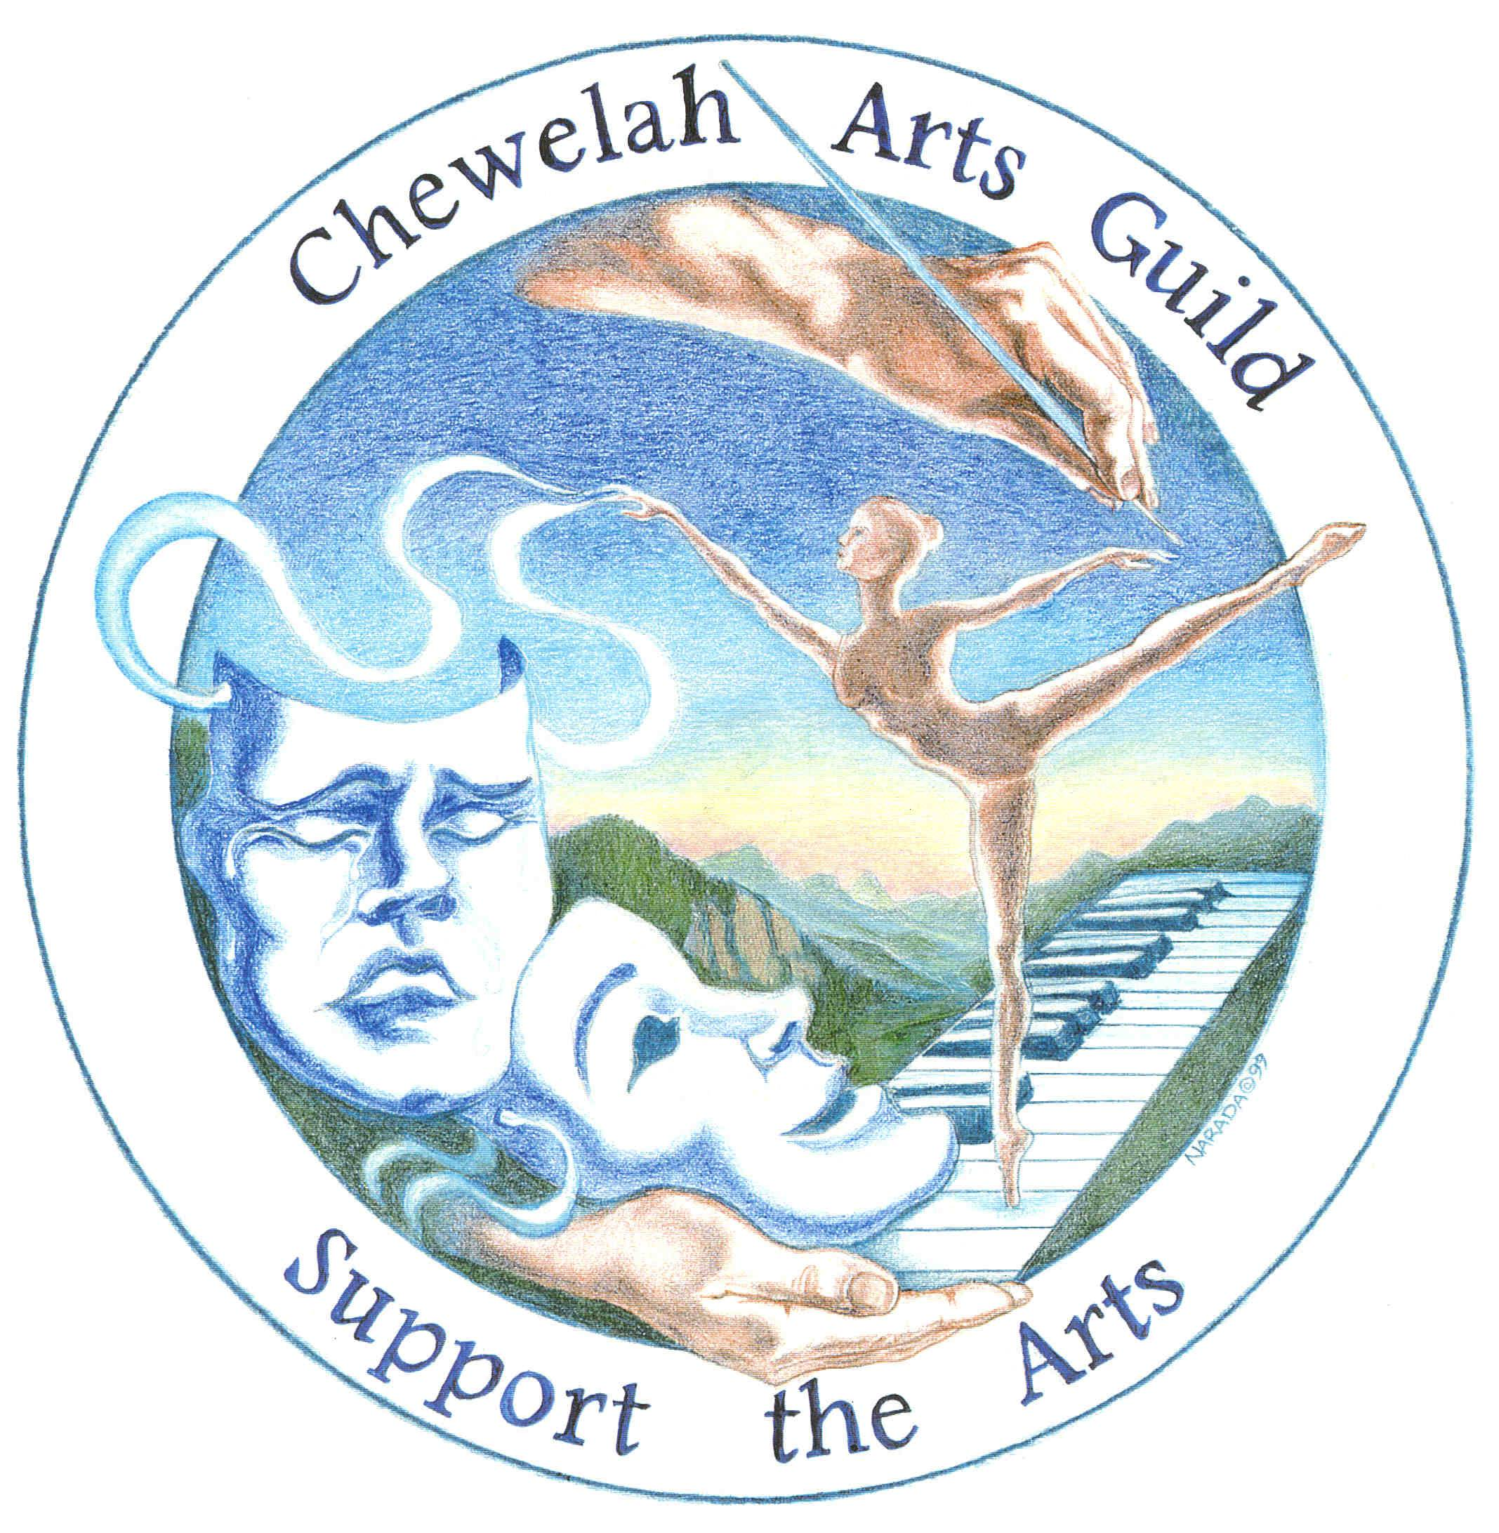
Thank you,
Diane Evans
Chewelah Arts Guild President

